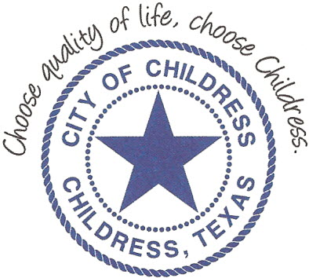
City of Childress
315 Commerce P.O. Box 1087 Childress, TX 79201
Phone: 940.937.3684 Fax: 940.937.6420

AGENDA

The City Council will meet in Regular Session, Monday May 10th, 2021 at 6:00 p.m. in the Expo Center at the Mashburn Event Center, 1100 7th St. NW, Childress Texas to discuss the following:
Action Items

- Call meeting to order with Invocation and Pledge of Allegiance.
- Public Comment.
- Approve or amend and approve Minutes from 04/12/2021.
- Discuss/Approve FY ‘19-‘20 Audit report by Foster and Lambert.
- Discuss/Act on request to add batting cages to the girls’ softball field in Fair Park.
- Present Recognition Award to Mr. Steve Craig.
- Discuss/Act on Lease Agreement between City of Childress and Mr. Trevor Watson.
- Discuss/Act on Storm Siren Bids RFP 05-10-21-1:
Open bids for Storm Siren Project
Award bid contract.
- Discuss/Act 2021 Paving Project. Review and approve potential amendments, updates to figures and potential locations.
- Discuss/Approve on Budget Amendment #3.

Council may enter a closed session as permitted by the Texas Open Meetings Act, (Chapter 551 of the Texas Government Code).

____________________________
Kevin Hodges, City Manager
KH/dd
Posted 11:35 A.M. May 6th, 2021
Distribution: Red River Sun (email), KCTX Radio (fax)
Sworn to and subscribed before me this the 6th day of May 2021

____________________________________________
D’Linda Dockery, Notary Public State of Texas

