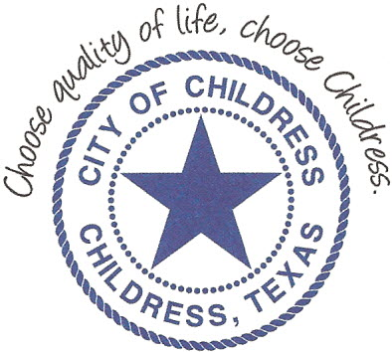
City of Childress
315 Commerce P.O. Box 1087 Childress, TX 79201
Phone: 940.937.3684 Fax: 940.937.6420

AGENDA

The City Council will meet in Regular Session, Monday, August 13th, 2018 at 6:00 p.m. in the Council Chambers at Childress City Hall, 315 Commerce St., Childress Texas to discuss the following:
Action Items

- Call meeting to order.
- Discuss/Act on renewing Advancing Line of Credit.
- Update on Revolving Loan Fund.
- Discuss/Act on ordinance regarding foul odor as a public nuisance.
- Discuss/Act on Hotel Occupancy Tax allocation.
- Discuss/Act on alcohol sales ordinance relating to Allsup’s 601 Ave F NW location.
- Discuss/Act on proposed false alarm ordinance relating to Police Department.
- Discuss/Act on leashing signage at Fair Park.
- Discuss/Act on Council benefits.
- Consider resolution directing posting and publication of requests for qualifications and proposals from engineering firms, financial advisors, and bond counsel to provide professional services related to the improvement of the City’s water & wastewater system.
- Discuss/Act on storm sirens & relating Emergency Management Coordinator position and agreement.
- Submit/Approve 2018 Certified Appraisal Roll.
- Submit effective and roll back rates.
- Discuss and propose 2018 tax rate.

Council may enter a closed session as permitted by the Texas Open Meetings Act, (Chapter 551 of the Texas Government Code).

____________________________
Kevin Hodges, City Manager
KH/dd
Posted 3:00 P.M. August 10th, 2018
Distribution: Index (email), KCTX Radio (fax)
Sworn to and subscribed before me this the 10th day of August 2018

____________________________________________
D’Linda Dockery, Notary Public State of Texas

