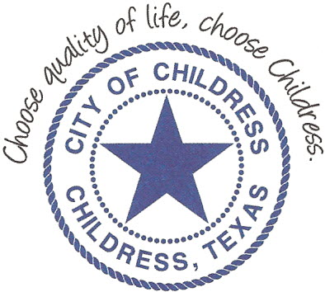
City of Childress
315 Commerce P.O. Box 1087 Childress, TX 79201
Phone: 940.937.3684 Fax: 940.937.6420

NOTICE OF PUBLIC HEARING

The City Council will meet for a Public Hearing, Friday July 30th, 2021 at 6:00 p.m. in the Expo Center of Mashburn Event Center, 1100 7th St. NW, Childress Texas to consider the following:

Discuss the appeal of interested parties’ denial of zoning request by Childress I.S.D. Discuss assigning zoning for proposed Ag Farm to 6 additional blocks (Ave I & Ave J, 8th St. NE Lots 1-6 Blk 163 OP)

The Planning and Zoning Commission may recommend, and the City Council may consider acting on the stated amendments.

____________________________
Kevin Hodges, City Manager
KH/dd
10:45 A.M. July 20th, 2021
Distribution: Red River Sun (email), KCTX Radio (fax)
Sworn to and subscribed before me this the 20th day of July 2021

____________________________________________
D’Linda Dockery, Notary Public State of Texas

