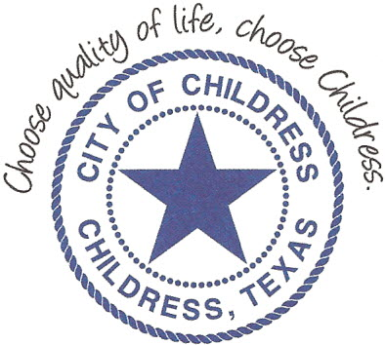
City of Childress
315 Commerce P.O. Box 1087 Childress, TX 79201
Phone: 940.937.3684 Fax: 940.937.6420

AGENDA

The City Council will meet in Called Session, Monday May 10th, 2021 at 5:55 p.m. in the Expo Center at the Mashburn Event Center, 1100 7th St. NW, Childress Texas to discuss the following:
Action Items

- Call meeting to order.
- Public Comment.
- Canvass votes for the May 1, 2021 General Election.
- Swear in Elected Officials.

Council may enter a closed session as permitted by the Texas Open Meetings Act, (Chapter 551 of the Texas Government Code).

____________________________
Kevin Hodges, City Manager
KH/dd
Posted 11:30 A.M. May 6th, 2021
Distribution: Red River Sun (email), KCTX Radio (fax)
Sworn to and subscribed before me this the 6th day of May 2021

____________________________________________
D’Linda Dockery, Notary Public State of Texas

